
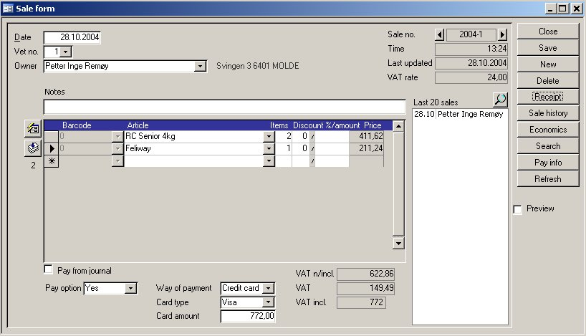
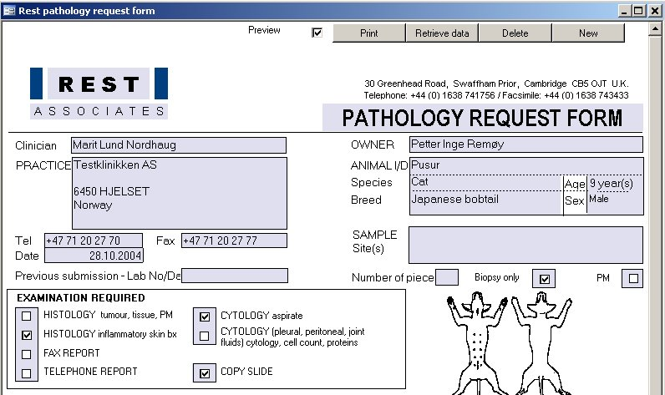
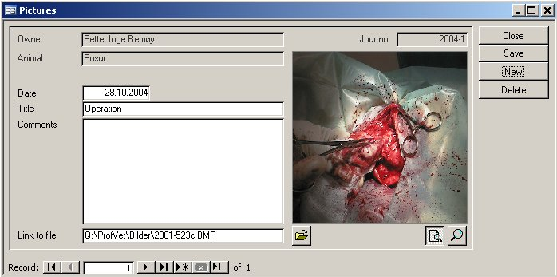
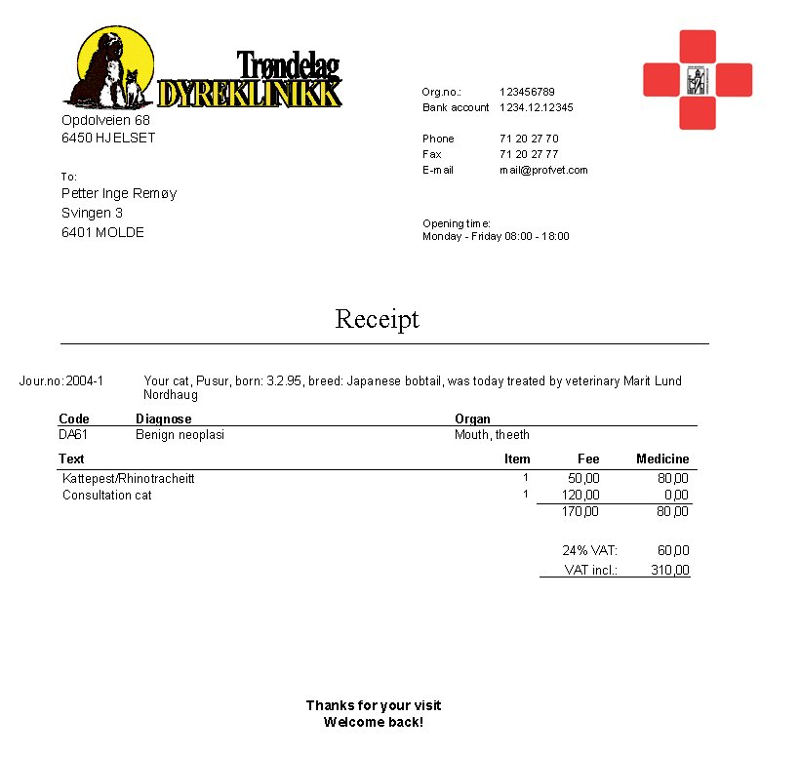
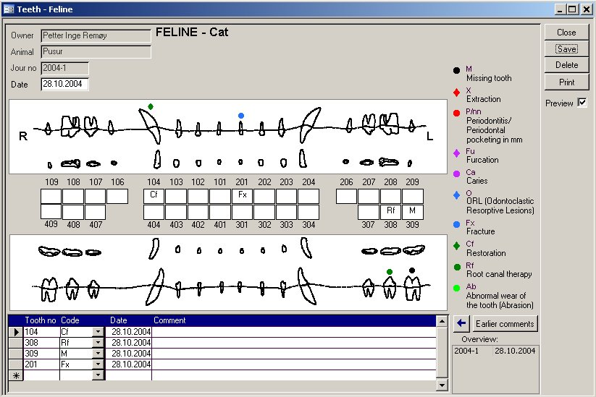
ProfVet International AS
Postbox 38  6454 Hjeslset  Norway  Tlf: 71 20 27 70 | mail@profvet.com

Forms and certificates
More than 40 forms and certificates are available from within the program. Animal and owner information is automatically entered.
Reports
A great number of reports can be printed. Economic surveys, search results, summaries by customer, veterinarian, day, etc.
Customer correspondence
Standard text for all types of letters can be entered and stored.. Mail merge allows the insertion of personal data in letters to customers.
Graphical surveys
Graphical surveys are provided, covering e.g. weight development in an animal, economic surveys for the clinic or for each veterinarian per month.
Appointments
A tidy appointment system that shows visually available appointments by veterinarian, assistant and clinic facility.
Periodic checks
When you have decided that a certain treatment is a periodic check (like vaccination or heat period treatment), a letter of summons will be issued when the time for a new treatment is drawing near.
Invoicing
Function for invoicing of customers that can be run whenever convenient.
Reminders
Function for issuing of reminders, where you can determine whether a reminder is to be sent and how many reminders to be sent before the debt is sent for collection.
Customer accounts
Economic surveys for each customer.
Stock inventory with bar code reader
An additional module provides access to stock inventory with bar code reader.
Cash register and payment terminal management
An additional modules lets the journal program manage the cash register and payment terminal, thereby avoiding problems with erroneous amounts or method of payment.

